
Age Friendly Calderdale
Accreditation


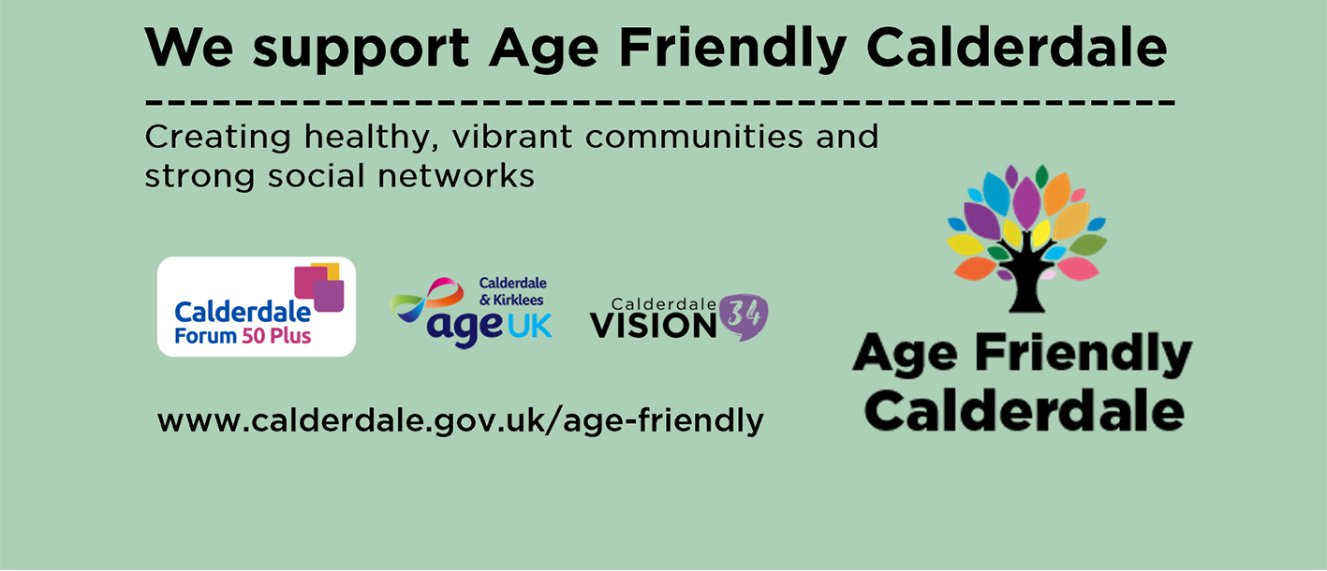

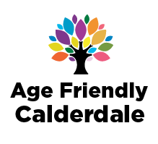
Age Friendly Calderdale
Age Friendly Accreditation Scheme
Introduction
We want Calderdale to be a place where older people (aged 50 and over) have strong social networks and live in healthy, vibrant communities. Age Friendly practices help create environments, services and opportunities that are welcoming, accessible and inclusive for older people, enabling them to participate fully in community life.
The over-50s are the fastest-growing demographic in the UK and currently make up around 40% of Calderdale's population. As our population ages, it becomes increasingly important that the spaces, places and services people use every day are designed to support independence, wellbeing, participation and social connection.
Age Friendly approaches benefit everyone. Features such as clear information, accessible environments, welcoming staff and opportunities for feedback make spaces easier to use for people of all ages and abilities.

Who is this scheme for?
The Age Friendly Spaces Accreditation Scheme is open to organisations, community groups, public services, cultural venues, leisure facilities, faith organisations, businesses and any other setting that welcomes members of the public.
We encourage organisations across Calderdale to take simple, achievable steps that support the needs of older people and contribute to creating a more inclusive community.
Being Age Friendly is not about achieving a standard once. It is an ongoing commitment to reviewing and improving how people experience your space, service or organisation, and making changes wherever possible to meet the diverse needs of older people.
This checklist has been designed to support organisations to identify practical actions that can help create a more Age Friendly environment.
Age Friendly Calderdale and its partners can support organisations to become Age Friendly and help identify the small changes that can make a significant difference to older people, their families and the wider community.

Why become Age Friendly?
Creating Age Friendly spaces helps older people feel welcomed, valued and included in community life. Older people make significant contributions to communities as volunteers, carers, workers, community leaders, service users, customers and active citizens. By considering their needs, organisations can improve access, participation and wellbeing for a large and growing part of the population.
Age Friendly environments are often better for everyone. Improvements such as clearer signage, better lighting, accessible information, comfortable seating and inclusive communication can benefit people of all ages and abilities.
Benefits of becoming Age Friendly
- Improves accessibility and inclusion.
- Supports independence and participation.
- Creates welcoming and respectful environments.
- Enhances the experience of visitors, service users, customers and community members.
- Helps staff and volunteers feel more confident in supporting diverse needs.
- Contributes to Calderdale's vision of being an Age Friendly place.

It’s easy to become more Age Friendly
This resource is designed to help you consider how your organisation, service or space could become more accessible and inclusive for older people.
In three simple steps you can become Age Friendly:

- Read through the Age Friendly actions under the three themes:
  - Welcoming and Respectful
  - Physical Environment and Accessibility
  - Communication and Information

- Sign up to become an Age Friendly Space. You can download this pack from Calderdale Forum 50 Plus at https://calderdaleforum50plus.com/age-friendly-calderdale/ This pack provides all the information that you will need to register as an Age Friendly Calderdale place.

- Choose as many Age Friendly actions as possible that will make a positive difference to the people who use your organisation, service or space. We recommend starting with the actions highlighted in bold, but it is important to choose actions that are appropriate and achievable for your setting.

Once complete you should return the relevant forms via email to agefriendly@calderdale.gov.uk Your application will be assessed, and you may receive a visit from one of our Ageing Well Ambassadors.
How will people know I’m an Age Friendly place?
When you sign up, you’ll be provided with an Age Friendly window sticker (see below) and have the opportunity to have your place listed on the Age Friendly Calderdale webpage, Calder Connect Community Information Directory, Visit Calderdale Website and the Calderdale Forum 50 Plus Age Friendly Calderdale webpage.

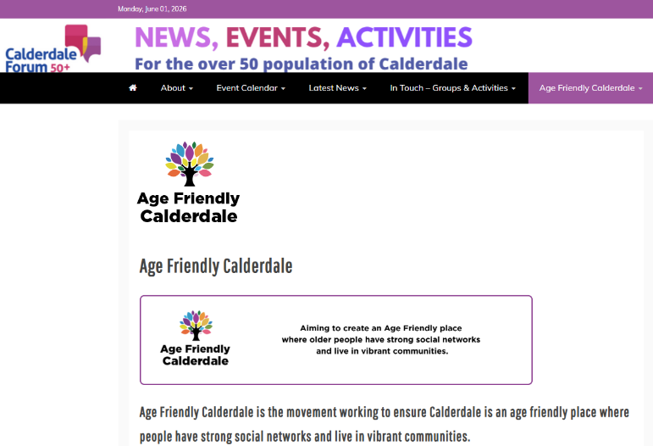
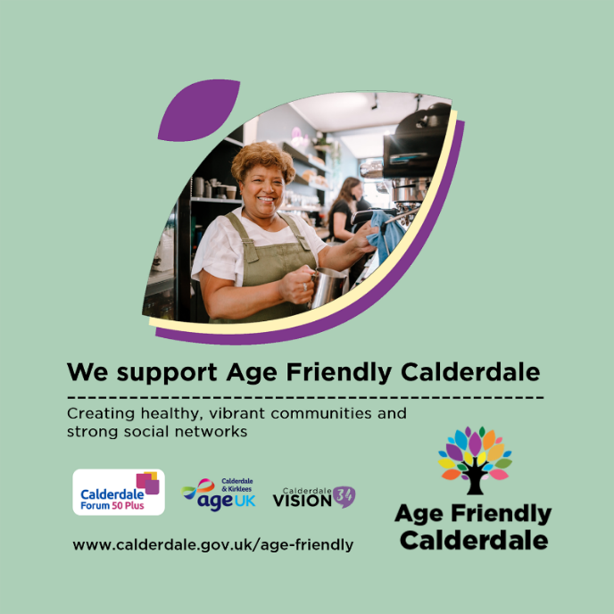
Window sticker example Calderdale Forum 50 Plus Website

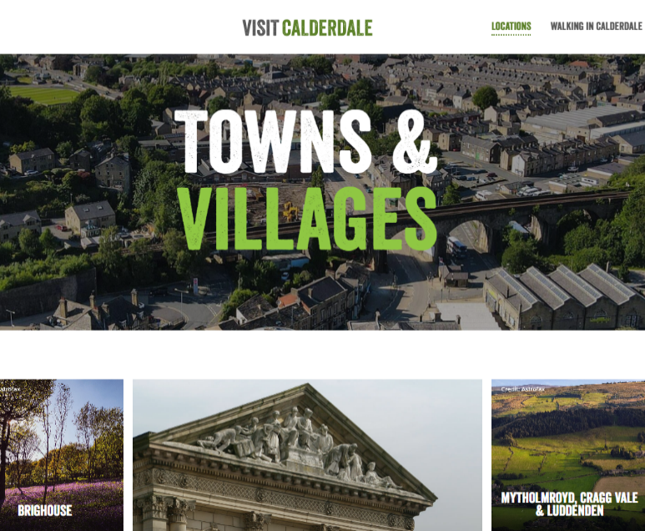
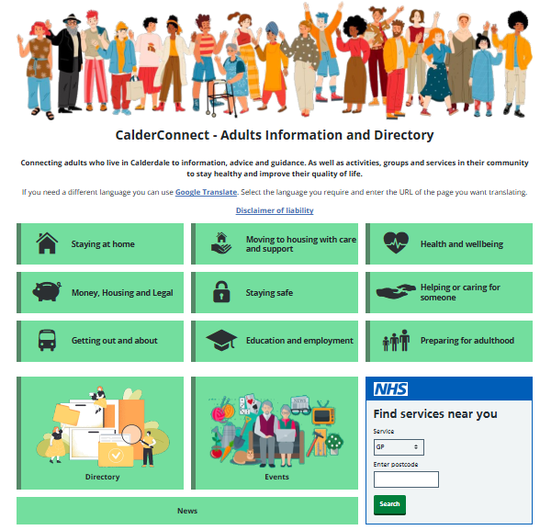
Calder Connect Directory Visit Calderdale Website

The following four pages include a section for your details and three themed checklists.
Please complete all four pages. We recommend that you start with the actions highlighted in bold, but it is important to choose actions that are appropriate and achievable for your organisation.
If you can’t meet all of the criteria in bold, don’t worry. There may be some criteria that your organisation or space cannot accommodate. Your commitment to providing an age friendly environment and service is important, and you may be able to demonstrate this in other ways. You can provide additional information to support your application if you choose.
When you have completed your details and the three checklists, please return via the following email address with the name and contact details of your business clearly stated.
Please return to: agefriendly@calderdale.gov.uk.

Your Details
Space or Organisation Name
Address

Postcode

Contact name (Person completing this application)
Contact email

Contact Telephone

Welcoming and Respectful
A friendly face, patience and understanding can have a big impact on someone’s day. If public-facing staff are actively welcoming to everyone, it can make a real difference to someone who may need assistance or be socially isolated.
Age Friendly Actions |  | How do you achieve this or plan to achieve this and by when?
Make sure staff are patient, friendly, face the person, speak clearly, listen and provide straightforward instructions or advice.

Older people come from a diverse range of backgrounds. Do you display signage and imagery that is welcoming to all and are promotional materials representative of older people – showing positive images?
You can access the free to use age positive image library (https://ageing-better.org.uk/news/age-positive-image-library-launched) from the Centre for Ageing Better https://ageing-better.org.uk/

Is there an easy way for people to provide feedback about what they like or what could be improved?

Physical Environment and Accessibility
We all know the importance of making buildings accessible for wheelchairs and mobility aids but there are many other things that you can put in place easily or free of charge, that will make your physical environment welcoming.
Age Friendly Actions |  | How do you achieve this or plan to achieve this and by when?
Ensure entrances are welcoming and accessible, with no obstructions, so people can come and go easily.
Unsure? Use this guide from Scope https://www.scope.org.uk/about-us/accessibility-at-scope/accessibility-guidelines/physical-accessibility-guidelines
Where toilet facilities are available, ensure they are clearly signposted, accessible and available to visitors where appropriate.
Ensure someone in a wheelchair can easily access your premises and that the layout of furniture or aisles allow for easy movement of all customers.
Offer a seat where people can sit down without needing to spend money. Chairs should ideally have arms and be sturdy.

Ensure facilities, resources, information and services are easy to access. Where assistance may be needed, make sure support is available

Provide alternative ways for people to access information and services, including telephone or face-to-face contact where possible

Do you know how easy it is to get to your premises (blue badge parking, bus stop). Do you provide details of the above on “how to find us” information?

Are steps and stairs clear of obstacles, well lit, with two handrails in a contrasting colour to the wall?

Communication and Information
Communication affects how information reaches your visitors and informs them of whether your space is relevant to them. Wording and design are important, and it’s crucial that information is clear, attractive and inclusive.
Age Friendly Actions |  | How do you achieve this or plan to achieve this and by when?
Make sure it is easy for people to find your premises or space, such as opening hours and accessibility both online and offline.
Use large, clear fonts for signage, printed materials and website etc.
Ensure amenities are clearly signposted. This is particularly important for lifts, accessible toilets, and hearing loop access.
Arts, culture, history and tourist venues should make sure large print, audio or braille versions of guides are available, and consider offering free tickets for carers.

Please return your details and the three checklists via email to: agefriendly@calderdale.gov.uk
If you have completed a paper copy, you can return it to:
Age Friendly Calderdale, Public Health, Chief Executive’s Office, 3rd Floor, Princess Building, Princess Street, Halifax HX1 1TS. agefriendly@calderdale.gov.uk
Or simply drop it in at:
Age UK Calderdale & Kirklees (Halifax).

Did you know?
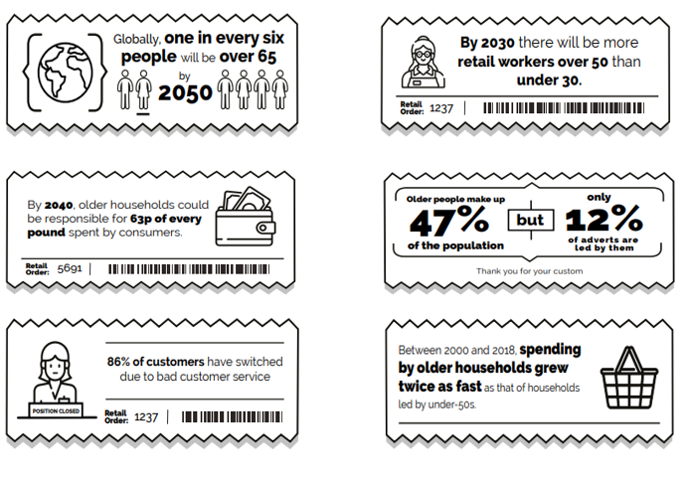
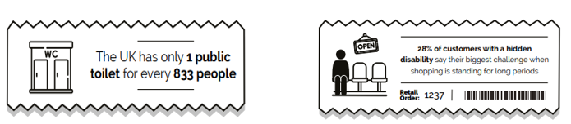

Source: International Longevity Centre UK

Did you also know?
That by working to become Age Friendly you are also meeting many of the requirements that make you Dementia Friendly!
Why not take the Calderdale Dementia Friendly Communities (CDFC) pledge?


Calderdale Dementia Friendly Community (CDFC) provides support, advice and guidance to businesses and community organisations across Calderdale. CDFC supports and encourages the development of dementia-friendly initiatives that improve access to spaces, places and services in Calderdale. The Pledge is one initiative that asks businesses and community organisations to make a ‘pledge to make Calderdale a dementia friendly community’ and sign up to 3 key actions:
- Our staff will become dementia friends - We will commit to all of our staff becoming Dementia Friends. They will increase their understanding of dementia and help to break down stigma (a Dementia Friends session takes 45-60 minutes)
- We will review our premises to look for improvements - We will use an environmental checklist to review our premises and make any changes we can to improve access and the experience for our customers affected by dementia. This will also help a wide range of our customers.
- We will actively support and promote the dementia friendly community - We will actively promote Calderdale as a community working to become dementia-friendly. We will talk to our customers and fellow businesses about why we are involved and the benefits we are experiencing as a result.
For those businesses and community organisations that are able to more, CDFC suggests additional actions for consideration, and provides links to a range of supportive resources.
Find out more about CDFC on their website www.calderdaledementiafriendlycommunity.co.uk/ or download their starter pack here.
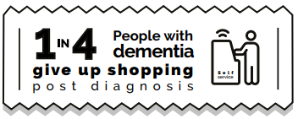
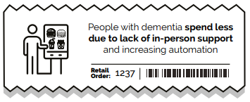

Dementia
Dementia
Dementia is an umbrella term that describes the symptoms that occur when the brain is affected by certain diseases or conditions. Symptoms may include memory loss and difficulties with thinking, problem-solving or language.
Although age is the biggest risk factor, dementia is not an inevitable part of ageing. The Chief Medical Officer’s Annual Report 2023: Health in an Ageing Society highlights that most people enter older age in good health and remain in good health sufficient to have independence and a high quality of life. About 2 in 100 people aged 65 to 69 years have dementia, and this figure rises to 19 in 100 for those aged 85 to 89.
Scientific evidence is evolving rapidly, and it is now thought that up to 40% of dementia cases might be attributable to potentially modifiable risk factors. This means that there are things that we can all do to reduce our risk.
- Don’t smoke – Smoking affects the blood supply to the brain and is one of the biggest lifestyle risk factors for dementia
- keep cholesterol and blood pressure under control
- be active and exercise regularly
- maintain a healthy weight
- eat a healthy balanced diet
- drink less alcohol.
There are several protective factors that can lower the risk of developing dementia associated with engaging in cognitive stimulation, such as reading, doing puzzles, or learning a language. Being socially active (for example meeting friends or volunteering) can also help to reduce dementia risk by:
- improving your mood
- relieving stress
- reducing the risk of depression
- reducing loneliness
Support to maintain a healthy lifestyle is available in Calderdale through the Better Living Service and Active Calderdale.
For more information about reducing your risk of Dementia download the Alzheimer’s Research UK booklet.
For further support, living with or caring for someone with Dementia, you can contact the Calderdale Dementia Hub or Calderdale Dementia Friendly Community

Age Friendly Calderdale
Age Friendly Calderdale is the movement working to ensure Calderdale is an age friendly place. A place where people have strong social networks and live in healthy and vibrant communities.
The movement is led by the Calderdale Ageing Well Alliance. The Alliance sees statutory and voluntary organisations in Calderdale work together. The alliance challenges negative stereotypes about ageing. It does this by supporting people and organisations to be more age-inclusive and to promote age friendly practices.
Find out more about Age Friendly Calderdale
Age UK Calderdale and Kirklees is a local charity, affiliated to the national charity Age UK, which came about through the merger of Age Concern and Help the Aged. We are responsible for choosing and funding all of the services we provide locally.
We help older people by providing practical, reliable services, letting you live the independent life you want and giving your family the peace of mind, knowing that you are being well looked after.
Our priorities
- To put older people at the centre of everything we do
- To provide accessible, effective and reliable services and to strive to continuously improve these for our customers
- To grow our range of services and to work with other organisations to expand opportunities to help more older people enjoy later life
Find out more about Age UK Calderdale and Kirklees
Calderdale Forum 50 Plus is the community group and online newspaper for older people in Calderdale.
We support and represent people aged 50 and over in Calderdale and highlight information and issues which are useful and important to this age group. We also signpost and connect older people to local groups, clubs, societies, charities, as well as events and service providers. We collate guidance on key later life issues such as housing, benefits and finance, care of all kinds and physical and mental health.
We work closely with Calderdale Council, NHS Calderdale, local charities and community groups serving older people and our content is widely shared on other websites and social media. In 2020 we were nominated for a Community Spirit award for our communications during the COVID-19 crisis.
Find out more about Calderdale Forum 50 Plus

Calderdale Dementia Hub is a partnership between Inspire North and Age UK Calderdale & Kirklees and offers an information and advice service for anyone of any age diagnosed with dementia, and their friends, family and carers. The aim of the Calderdale Dementia Hub is to ensure people within the Calderdale community have access to a wide range of dementia information and advice.
Find out more about Calderdale Dementia Hub
Calderdale Dementia Hub is a member of Calderdale Dementia Friendly Community (CDFC). CDFC works to develop and maintain a dementia friendly Calderdale through advice and support to businesses to help ensure that all Calderdale is as accessible to people affected by dementia as possible. To access our awareness sessions or on-site visits contact cdh@commlinks.co.uk in the first instance.

Join the Age Friendly Calderdale Network
In partnership with Calderdale Forum 50 Plus and Age UK Calderdale & Kirklees the Age Friendly Calderdale Network will:
- Champion the voices of those aged 50 and over
- Share ideas for making Calderdale an Age Friendly Community
- Provide opportunities to get together, share experience and celebrate the contributions older people make to Calderdale
The network is open to anyone aged 50 plus and any organisation that provides support, services or opportunities for older people.
Sign up here: Join the Age Friendly Calderdale Network or complete the sign up form available from Age UK Calderdale Kirklees.
It's free to sign up and you will receive the Calderdale Forum 50 Plus newsletter to keep you informed about Age Friendly Calderdale and the things that matter to you.
Age Friendly Calderdale is a member of the UK Network of Age Friendly Communities.


For more information or for support with this scheme, please contact:
Age Friendly Calderdale
Public Health
Chief Executive’s Office
3rd Floor, Princess Building
Princess Street
Halifax HX1 1TS
agefriendly@calderdale.gov.uk

More information and Links
Age UK Age Friendly Businesses
www.ageuk.org.uk/
Centre for Ageing Better – How to be an Age Friendly Business
www.ageing-better.org.uk/
International Longevity Centre UK – Healthy Retail – Healthy Ageing
International Longevity Centre UK – Healthy Retail – Hints and tips on accessibility
www.ilcuk.org.uk/
The Buildings Regulations 2010 – Access to and use of buildings – Buildings other than dwellings
www.legislation.gov.uk/uksi/2010/2214/contents
Visit Calderdale - Accessible Calderdale
www.visitcalderdale.com/blog/accessibility/
If you would like more information about accessibility or would like to have an accessibility audit conducted by a trained assessor, contact Visits Unlimited www.visitsunlimited.org.uk/

For more information or for support please contact:
Age Friendly Calderdale, Public Health, Chief Executive’s Office, 3rd Floor, Princess Building, Princess Street, Halifax HX1 1TS. agefriendly@calderdale.gov.uk
Acknowledgements
This resource has been adapted from the Age and Dementia Friendly Brighton & Hove Age and Dementia Friendly Business Recognition Scheme and the Age and Dementia Friendly Checklist produced by Age Friendly Middlesborough

