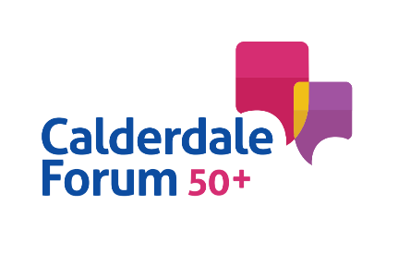
Calderdale Forum 50 Plus

Meeting on 7th May 2024

Copley Mill House

2.00pm start

AGENDA

Part 1 - Annual General Meeting

- Welcome

2. Overview of the Forum’s last year

3. Accounts and financial position

4. Charitable application

5. Election of Committee members

Part 2 - Committee Meeting

6. Communication Update

7. Older People’s Mental Health Consultation update

8. Funding Opportunities

9. Any other Business

10. Next Meeting

